|  |  |
| --- | --- |
| Module | rDQ Development Setup |
| Sub-Module |  |
| Author | D Twaddell |
| Date | 19th Aug 17 |
| Reviewer |  |
| Review Date |  |
| Review Status |  |
| Review Comments |  |

# Design Summary

## Design Log

## Sub-Module Description

1. Describe how to set up folder structure.
2. Describe global, common, and helper R functions. These should be used to ensure a common approach, and to reduce effort

## Sub-Module Context

System Development – not an application deliverable

## Data Model

TBA

# Design Details

## Folder structure:

rDataQuality > Module Name > SubModule Name

* Scripts (contains all scripts and code)
* data
  + input (all input data specific to the submodule)
  + output (all output data from the submodule)
* reports (all reports produced by the submodule)

Global

# Appendix – Module List

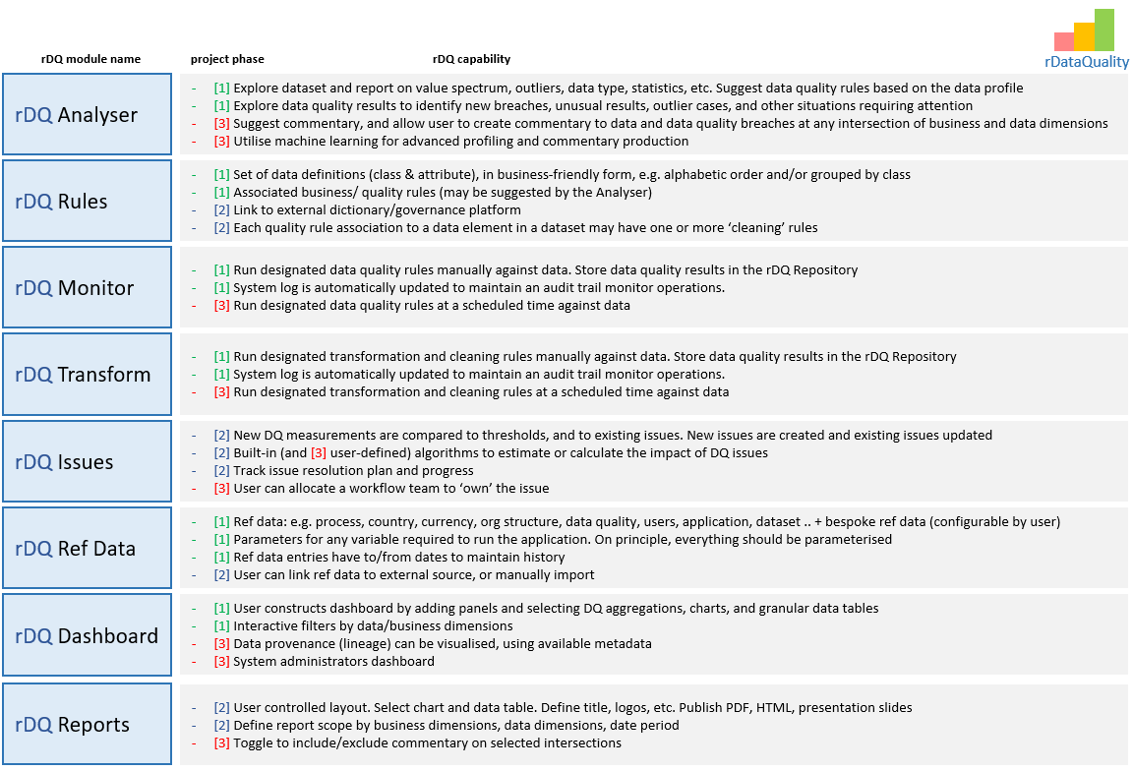

In addition to these ‘public’ modules we may need some private modules to help organise work, e.g.:

* **rDQDataManagement** – common functions relating to data management, dealing with files and database operations. Define functions that are used in other modules. Define global variables
* **rDQUI** – implements the user interface, using Shiny